Challenge: Flag Command

# Challenge Description:

**Embark on the "Dimensional Escape Quest" where you wake up in a mysterious forest maze that's not quite of this world. Navigate singing squirrels, mischievous nymphs, and grumpy wizards in a whimsical labyrinth that may lead to otherworldly surprises. Will you conquer the enchanted maze or find yourself lost in a different dimension of magical challenges? The journey unfolds in this mystical escape!**

# Context:

## Inspect the code of a web-application for a game, with the use of your analyst skills can you beat it and get the Flag.

# Notes:

* Make using you Look carefully and precisely ,You can complete this with just a browser

# Flag:

* First start the Instance then when it's running head straight to the web-page and open up the inspect-element prompt / developer tool.

With that we go to the network and see all the files it's pulling to work on that web-page, we get some interesting hits called Commands.js, Game.js and Main.js.

* Checking up on Game.js gives up nothing, same with Commands.js
* But When we inspect Main.js we can see the valid options for each step we need to take in the game.
* When I start sending the correct options I get stuck on a final page and all options fail, after looking closer I see that all the options I input also goto a API endpoint all “API/Monitor” Exploring that leads to a dead end.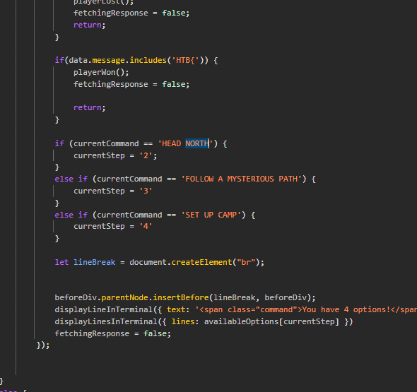
* The Last resort way to double check the network and i'm glad i did, is expose another endpoint called ”/API/Options” Following it Provided an extra Command to input, but where and when.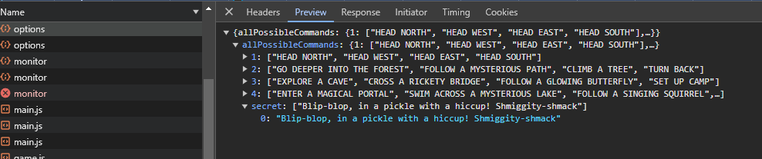
* Looking at the Main.js I see it can be executed right after I input the START command at the beginning.
* I input enter and then the Special Option and BAMMM, Easy Flag

# Flag:

* First Download PRET from github, then run it against the IP:PORT from the

We get the flag : **HTB{D3v3l0p3r_t00l5_4r3_b35t__t0015_wh4t_d0_y0u_Th1nk??}**

